**PUSL2010 Analysis**

**RANUL**

* The supermarket being a large network and operating daily requires a lot of capacity within the system handle numerous transactions without failure.
* As the business grows more and more data would be transferred and stored to keep the business in firmly stable with the competition, this requires new equipment to handle network traffic, faster storage drives, accurate GPS modules and more robust IPDS so as the requirements grow more space is required for them. Virtualization could help to overcome this problem in a more economical way sustaining the traditional servers within the chain.

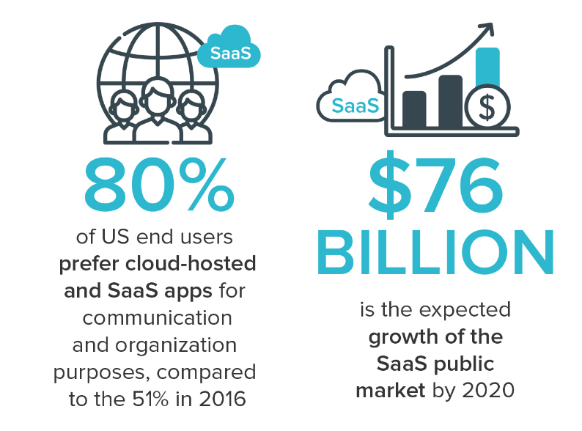

Figure : Illustration of trends for SaaS (AALPHA, 2020)

* Most business platforms today run on the Cloud, this helps to work on the go for staff and reduces extra store space required to store serves, and maintenance costs. Due to fact that most business move the SaaS model (Software as a Service), it will be profitable for the Supermarket chain to move the IT Infrastructure to the Cloud. (FinancesOnline, 2020)
* Upgrade will make expansions and future upgrades to the IT Infrastructure more flexible and safer from damages as personalized services as offered by partners businesses. If the Company requires to store company’s sensitive material, the old servers can be utilized for this, making the upgrade more economical and approachable to the company.
* Statistics show increasing trends for people requiring to work from home and for administrators requirements to maintain systems from one service point where actions can be assigned, monitored and controlled. This shows clear evidence for the requirement of the supermarket chain to move to cloud-based infrastructure as studies done by FlexJobs and Global Workplace Analytics shows “that there has been a major upward trend in the amount of people working remotely in the U.S. In the span of one year, from 2016 to 2017, remote work grew 7.9%. Over the last five years it grew 44% and over the previous 10 years it grew 91%. Between 2005 to 2017, there was a 159% increase in remote work. In 2015, 3.9 million U.S. workers were working remotely. Today that number is at 4.7 million, or 3.4% of the population.” (flexjobs, 2020)

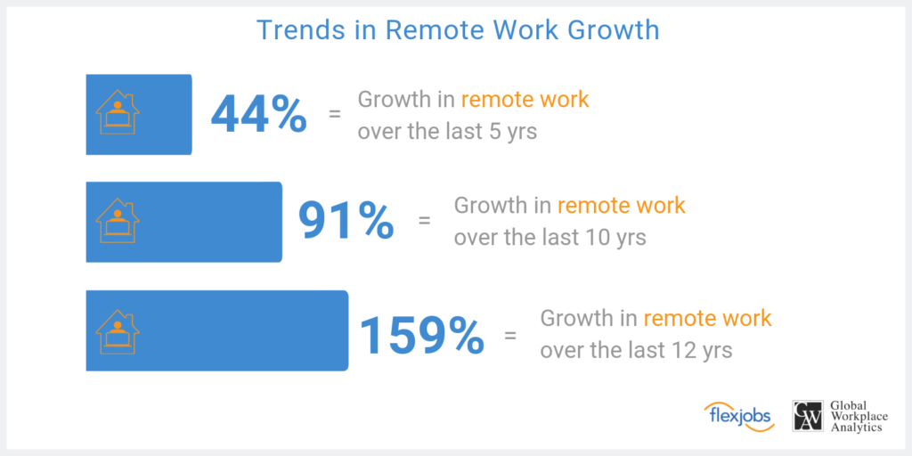

Figure : Illustration of Growth in Remote Work (flexjobs, 2020)

**References**

AALPHA (2020) *saas users preference*. Available at: <https://www.aalpha.net/blog/how-to-develop-a-cloud-based-saas-application-software-product/attachment/saas-users-preference/> (Accessed: 02 April 2020).

FinancesOnline (2020) *62 SaaS Statistics You Must Learn: 2020 Market Share & Data Analysis*. Available at: <https://financesonline.com/saas-statistics/> (Accessed: 02 April 2020).

flexjobs (2020) *Remote Work Statistics: Shifting Norms and Expectations*. Available at: <https://www.flexjobs.com/blog/post/remote-work-statistics/> (Accessed: 03 April 2020).